Obituary

Professor Glyn O. Phillips

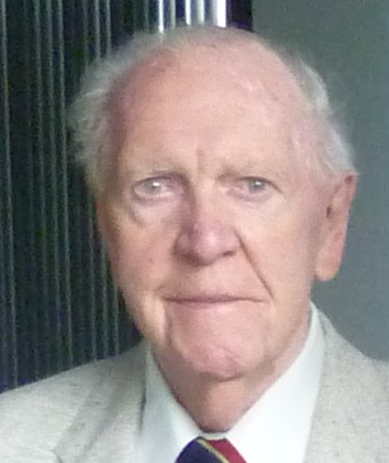

Glyn Phillips was born on November 6th 1927 and was brought up in Rhosllannerchrugog in his beloved Wales. He was the son of a coal miner and often told the tale that when he was a boy he also wanted to be a miner when he grew up. One day his father took him down the mine and shortly afterwards Glyn decided on a different career path. This was a very wise decision for him and indeed it has benefitted us all. Glyn obtained his BSc and PhD at the University College Bangor. He was appointed as a lecturer in chemistry at the University College Cardiff in 1954. He stayed there until 1967 and then moved to the University of Salford as Professor of Chemistry and Chairman of the Department of Chemistry and Applied Chemistry. He moved back to Wales in 1976 when he was appointed as Executive Principal of the North East Wales Institute (now Wrexham Glyndwr University).

He is a Fellow of the Learned Society of Wales and was awarded the honorary degree of Doctor of Science by the University of Benin in 1990 and an honorary degree of Doctor of Laws by the University of Wales in 1999. He was awarded the A.G. Evans Medal by the University of Cardiff in 1991, the first Science and Technology Medal by the National Eisteddfod of Wales in 2004 and the Food Hydrocolloids Trust Medal in 2007. He had a broad range of scientific interests and published more than 600 research papers in areas including radiation and free radical chemistry, radiation sterilisation, photochemistry and carbohydrate and polysaccharide chemistry. He was technical adviser to the International Atomic Energy Agency and editor of the journals, Food Hydrocolloids, Advances in Tissue Banking and International Journal of Cell and Tissue banking.

Glyn’s interest in polysaccharide gums came from his connection with the University of Benin, Nigeria where he was Foundation Vice-Chancellor in 1970 - 1971.When Glyn took up his appointment at the North East Wales Institute there was no science research but within 3 years there were substantive research groups working in the areas of polysaccharide chemistry, photochemistry, radiation chemistry and biochemistry. After attending a Seminar in London organised by FMC he decided that ‘we’ should organise a conference on hydrocolloid materials at the North East Wales Institute and this led to the Gums and Stabilisers for the Food industry series of Conferences. The first was held in 1981 and they have been held biennially ever since. From the start Glyn was keen to promote interaction between academic and industrial researchers and this has been a key factor in their success. The popularity of the Conferences led to the launch of the Food Hydrocolloids Journal in 1986.

When Glyn ‘retired’ from the North East Wales Institute in 1991 he started his second and highly productive career. He established the well-known Phillips Hydrocolloids Research Centre at the North East Wales Institute (2003 -2014) which was sponsored by San Ei Gen Inc, Japan. The Centre employed a significant number of staff, PDRA’s and PGR students and the research led to a highly significant number of peer-reviewed research papers. A second PHRC was opened at Hubei University of Technology, Wuhan, China which is still in operation today.

Glyn was very active up until fairly recently. We were planning to hold a Conference to celebrate his 90th birthday in St Tropez but he suffered a stroke shortly before this and it was cancelled. He had a full and active life and could always rely on the tremendous support from his wife Rhiain who travelled everywhere with him. He was an excellent scientist, very creative, a very good negotiator and very inspirational. He made things happen and most importantly was great fun to be with. He was also a very good ambassador for Wales and never forgot his roots. He will be sadly missed.

Professor Peter A. Williams
Wrexham Glyndwr University

