Curriculum for a Successful Future?
17 October 2019, Swansea University

220 people signed up via Eventbrite to join us on the evening; staff and speakers brought the expected number to 230. In the end, attending on the evening were 175 delegates plus staff and speakers. Of these, 102 delegates completed feedback cards; the response is summarised below.

A live stream was broadcast to an audience at Bangor University; the video exists on Youtube at
https://www.youtube.com/watch?v=7CWvdNvE3tI.

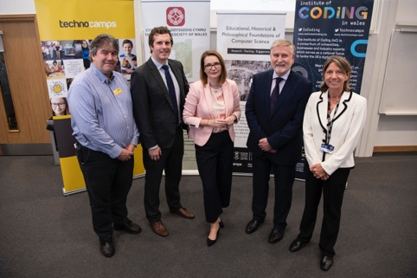

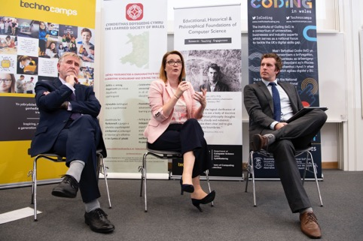

Analysis of Delegates feedback cards

Question 1. What Sector are you from?

86% of the delegates were from the education sector with two-fifths coming from Primary Schools.

Question2. To what degree was the event useful/ informative?

Two-thirds of the delegates found the lectures and Q&A session very useful/informative.

Summary of Comments
There were no negative comments provided. Overall there was high engagement and satisfaction
with the evening and the information presented.

Information on the Gatsby model mentioned informative. Q&A best part. Alma wrapped it up perfectly!
Useful focus on professional partnerships and how input is essential from range of services for centralised approach to new curriculum
Excellent panel!
A very motivating evening. Many thanks!
Beneficial to hear the vision so clearly articulated
Lots of interesting arguments
Encouraging to hear where education is going
It gave me a perspective from those that were/are involved in the process of the reform
Interesting presentations, relevant + useful good timings - each session lasted appropriate. time, venue very good, Q&A good
Good summary of the 'reasons' for change
Very thought provoking - exciting times ahead!
Enjoyed Prof. Donaldson's talk in particular helped decode unfamiliar language of new curriculum.
A good mix of looking back looking forward on how Wales can be really 'on the map' re Curriculum reform. Extremely interesting.
Valuable to know the landscape. Well-presented and clear to follow.
A very informative event. Honest Q&A.
An excellent evening. Further clarification and ideas to take forward.
Q&A (in some ways) best part. Maybe time next one differently?
As a Head Teacher. I embrace the opportunity to design a curriculum that our learners need!
Interesting points raised. Clear vision stated and explained. Look forward to seeing the investment in teachers.
Great to hear Prof. Donaldson speaking, definitely inspirational. Looking forward to seeing the curriculum changes.

