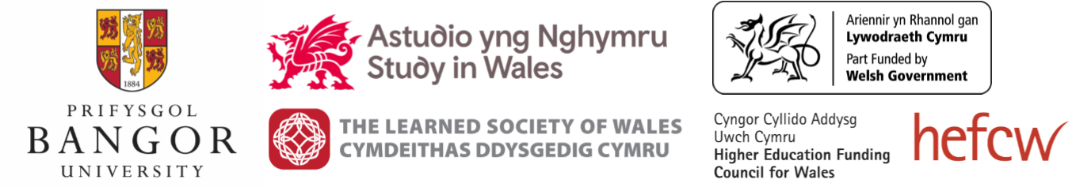

Universities as Global Communities

Bangor University – 13 February 2020

This event is jointly organised by Universities Wales and the Learned Society of Wales

Part of the Society’s Wales and the World event series – deepening understanding and discussion of the nation’s ‘soft power’

12.30
Lunch / networking / registration

13.20
Introduction to event themes; expectations for day
Sir Emyr Jones Parry – President, Learned Society of Wales

13.30
Session 1 – What is the Welsh sector’s position within UK and global contexts?

The View from Wales (experiences from Bangor, Global Wales and the sector as a whole)
Professor Iwan Davies – Vice-Chancellor, Bangor University / Chair of Global Wales

The UK View
Vivienne Stern – Director, Universities UK International

Panel discussion

14.30
Session 2 – How can the sector develop a more distinctive international image?

Projection of Wales as an internationally engaged/forward-looking nation
Professor Simon Haslett, Pro Vice-Chancellor (International and Enhancement), University of Wales Trinity Saint David

Working within the context of the Future Generations Act and the climate crisis
Dr Gavin Bunting, Associate Professor – College of Engineering, Swansea University

Table discussion and feedback

15.15
Break

15.35
Session 3 – How can Welsh institutions work more effectively with international partners?

International research collaboration
Professor Phil Stephens, Dean of International & Engagement, College of Biomedical and Life Sciences, Cardiff University

International campuses and outreach
Mark Cadwallader, Director of Strategy and Development, University of South Wales

Table discussion and feedback

16.15
Session 4 – How do people in Wales benefit from universities’ international connections?

Enriching culture and diversity
Dr Maggie Parke, Bangor University / Universities Wales

Developing civic engagement
Professor Cara Aitchison, Vice-Chancellor, Cardiff Metropolitan University

Audience discussion

16.45
Wrap up and recommendations

17.00
Close

