Honoured to receive Chinese Government Friendship Award and Medal

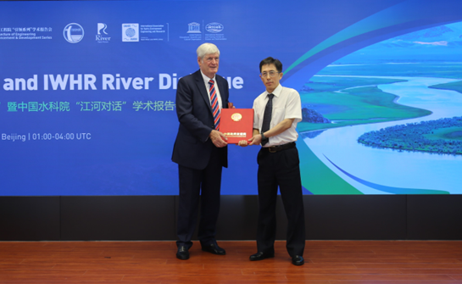

Having just returned from China I was delighted and honoured to receive the Chinese Government Friendship Award and Medal from Dr Zhu Jiang, Deputy Director, International Economic and Technical Cooperation and Exchange Centre (INTCE), Ministry of Water Resources. ‘The Friendship Award is the highest award to commend foreign experts’ who have ‘made contributions to China's modernization drive’ and I have benefitted immensely from collaborating with Chinese scholars and practitioners since 1981.

I first started collaborating with China through Tongji University and have since worked with several leading universities and government institutes. Examples include: (i) Tongji University: designing harbours and marinas to maximise water quality; (ii) Tsinghua University: developing a model CONTANK to reduce chlorine levels in disinfection tanks; (iv) Tianjin University and Municipal Government: modelling Bohai Bay and Sea to balance economic development of the Bay for increased shipping, balanced with minimal environmental impact; (v) Wuhan University: developing urban models and formulations for stability of people and vehicles in floods; (vi) Hohai University and the Yangtse Institute for Conservation and Presentation: collaborating on global water security and sustainable water management. Through these collaborations and Honorary Professor appointments at several universities and institutes, I have had the opportunity of co-authoring over 120 journal publications with Chinese scholars.

Whilst in China I also visited the Chinese Academy of Engineering (CAE) to receive the certificate of election as a Foreign Member in 2019 and delivered the second CAE Lead Lecture on ‘Global Water Security: Modelling for Sustainable Flood, Water Quality and Health Risk Assessment’ at a CAE LEADS and IWHR River Dialogue Livestreaming event.

